Simple task 1:
Problem: A researcher collected a list of numbers during an experiment. What was the smallest number he recorded?
Pattern: Minimum Selection
Specification: Specification editor
In: size ∈ N, nums ∈ Z[1..size]
Out: min ∈ Z
Pre: size > 0
Post: ( , min ) = MIN(i=1..size, nums[i])
Algorithm: Structogram editor
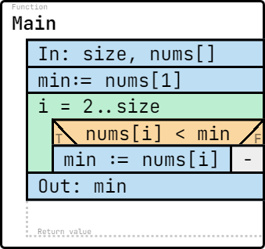
Test cases:
size: 5  nums: [3, 7, 1, 9, 5]  min: 1 | size: 4  nums: [10, 20, 30, 5]  min: 5 | size: 3  nums: [-1, -5, -3]  min: -5 | size: 2  nums: [-7, -1]  min: -7 | size: 1  nums: [100]  min: 100

namespace Task6
{
internal class Program
{
static void Main(string[] args)
{
Console.Write("Enter the size of the array: ");
int size = int.Parse(Console.ReadLine());

int[] nums = new int[size];

Console.WriteLine("Enter the elements:");
for (int i = 0; i < size; i++)
{
nums[i] = int.Parse(Console.ReadLine());
}

int min = nums[0];
for (int i = 1; i < size; i++)
{
if (nums[i] < min)
{
min = nums[i];
}
}

Console.WriteLine("Minimum element: " + min);
}
}
}

Questions:
1. Which pattern is applied in this task?
Answer: Minimum Selection
2.In the postcondition, what does MIN(i=1..size, nums[i]) mean?
Answer: It means the minimum value among all array elements between index 1 and size.
3.How many comparisons will be executed if size = 6?
Answer: 5
4. What is missing in the following algorithm? (What would you write instead of <?>)
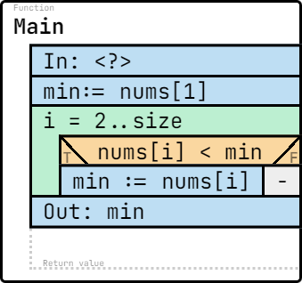

Answer: size, nums[]
5. What is missing in the following specification? (What would you write instead of <?>)
In: <?>
Out: min ∈ Z
Pre: size > 0
Post: ( , min ) = MIN(i=1..size, nums[i])

Answer:
size ∈ N, nums ∈ Z[1..size]

Simple task 2:
Problem: A data scientist recorded a series of integers and wants to know about the odd numbers among them. How many of the numbers were odd?
Pattern: Multiple Item Selection
Specification: (link)
In: size ∈ N, nums ∈ Z[1..size]
Out: cnt ∈ N
Pre: -
Post: cnt = COUNT(i=1..size, nums[i] mod 2 ≠ 0)

Algorithm: (link)
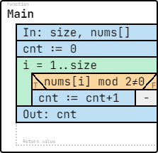

Test cases:
size: 5  nums: [1, -2, 3, 4, -5]  cnt: 3 | size: 4  nums: [2, 4, 6, 8]  cnt: 0 | size: 6  nums: [0, 1, 2, 3, 4, 5]  cnt: 3 | size: 3  nums: [-7, -1, -2]  cnt: 2 | size: 1  nums: [0]  cnt: 0

Code:
namespace Task2
{
internal class Program
{
static void Main(string[] args)
{
Console.Write("Enter the size of the array: ");
int size = int.Parse(Console.ReadLine());

int[] nums = new int[size];

Console.WriteLine("Enter the elements:");
for (int i = 0; i < size; i++)
{
nums[i] = int.Parse(Console.ReadLine());
}

int cnt = 0;
for (int i = 0; i < size; i++)
{
if (nums[i] % 2 != 0)
{
cnt++;
}
}

Console.WriteLine("Number of odd elements: " + cnt);
}
}
}

Questions:
1.Which pattern is applied in this task?
Answer: Multiple Item Selection
2. In the postcondition, what does COUNT(i=1..size, nums[i] mod 2 ≠ 0) mean?
Answer: It means counting how many elements in the array are odd, i.e., the number of elements between index 1 and size that satisfy the condition nums[i] mod 2 ≠ 0.
3. How many times will the condition nums[i] mod 2 ≠ 0 be checked if size = 6?
Answer: 6
4. What is missing in the following algorithm? (What would you write instead of <?>)
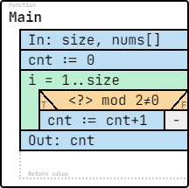
Answer: nums[i]
5. What is missing in the following specification? (What would you write instead of <?>)
In: size ∈ N, nums ∈ Z[1..size]
Out: cnt ∈ N
Pre: -
Post: cnt = COUNT(<?>)
Answer: i=1..size, nums[i] mod 2 ≠ 0

Simple task 3:
Specification: (link)
Problem: A quality inspector reviewed a list of measurements to see if any were below zero. Did he encounter any negative values?
Pattern: Decision
In: size ∈ N, nums ∈ Z[1..size]
Out: hasNeg ∈ L
Pre: size > 0
Post: hasNeg = EXISTS(i=1..size, nums[i] < 0)
Algorithm: (link)
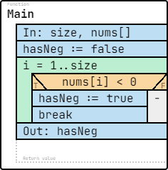
size: 5  nums: [1, 2, 3, 4, 5]  hasNeg: false | size: 4  nums: [2, 4, 6, 8]  hasNeg: false | size: 3  nums: [-7, -2, -3]  hasNeg: true | size: 2  nums: [-7, -1]  hasNeg: true | size: 1  nums: [0]  hasNeg: false

Code:
namespace Task3
{
internal class Program
{
static void Main(string[] args)
{
Console.Write("Enter the size of the array: ");
int size = int.Parse(Console.ReadLine());

int[] nums = new int[size];

Console.WriteLine("Enter the elements:");
for (int i = 0; i < size; i++)
{
nums[i] = int.Parse(Console.ReadLine());
}

bool hasNeg = false;
for (int i = 0; i < size; i++)
{
if (nums[i] < 0)
{
hasNeg = true;
}
}

Console.WriteLine("Contains negative number: " + hasNeg);
}
}
}

Questions:
1. Which pattern is applied in this task?
Answer: Decision
2. In the postcondition, what does EXISTS(i=1..size, nums[i] < 0) mean?
Answer: It means the result is true if there exists at least one element in the array between index 1 and size that is negative.
3. If size = 5, how many times will the comparison be executed in the worst case?
Answer: 5
4. What is missing in the following algorithm? (What would you write instead of <?>)
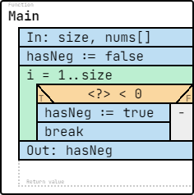
5. What is missing in the following specification? (What would you write instead of <?>)
In: size ∈ N, nums ∈ Z[1..size]
Out: hasNeg ∈ L
Pre: size > 0
Post: hasNeg = EXISTS(<?>)
Answer: i=1..size, nums[i] < 0

Simple Task 4:
Problem: An engineer measured a set of values and wants to be sure every one is above zero. Is it true that every number in the list is positive?
Pattern: Decision
Specification: Specification editor
In: size ∈ N, nums ∈ Z[1..size]
Out: allPos ∈ L
Pre: size > 0
Post: allPos = FORALL(i=1..size, nums[i] > 0)
Algorithm: Structogram editor
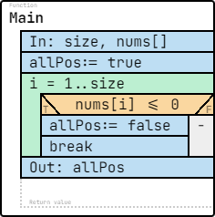
size: 5  nums: [1, 2, 3, 4, 5]  allPos : true | size: 4  nums: [2, 0, 4, 6]  allPos: false | size: 3  nums: [7, -2, 3]  allPos: false | size: 2  nums: [-7, -1]  allPos: false | size: 1  nums: [10]  allPos: true
Code:
namespace Task4
{
internal class Program
{
static void Main(string[] args)
{
Console.Write("Enter the size of the array: ");
int size = int.Parse(Console.ReadLine());

int[] nums = new int[size];

Console.WriteLine("Enter the elements:");
for (int i = 0; i < size; i++)
{
nums[i] = int.Parse(Console.ReadLine());
}

bool allPos = true;
for (int i = 0; i < size; i++)
{
if (nums[i] <= 0)
{
allPos = false;
}
}

Console.WriteLine("All numbers are positive: " + allPos);
}
}
}
Questions:
1. Which pattern is applied in this task?
Answer: Decision
2. In the postcondition, what does FORALL(i=1..size, nums[i] > 0) mean?
Answer: It means the result is true if every element in the array between index 1 and size is positive.
3. If size = 6 and all numbers are positive, how many comparisons are executed?
Answer: 6

4. What is missing in the following algorithm? (What would you write instead of <?>)
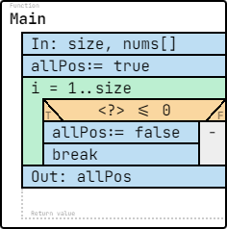
Answer: nums[i]

5. What is missing in the following specification? (What would you write instead of <?>)
In: size ∈ N, nums ∈ Z[1..size]
Out: allPos ∈ L
Pre: size > 0
Post: allPos = FORALL(<?>)
Answer: i=1..size, nums[i] > 0

Simple task 5:
Problem: A shop worker has ended a shift and wants to know the total amount of all transactions made during the day. What is the total amount recorded?
Pattern: Summation
Specification: Specification editor
In: size ∈ N, nums ∈ Z[1..size]
Out: sum ∈ Z
Pre: size > 0
Post: sum = SUM(i=1..size, nums[i])
Algorithm: Structogram editor
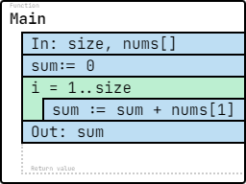
size: 5  nums: [1, 2, 3, 4, 5]  sum: 15 | size: 4  nums: [2, -1, 4, 6]  sum: 11 | size: 6  nums: [10, 20, 30, 40, 50, 60]  sum: 210 | size: 3  nums: [-7, -2, -3]  sum: -12 | size: 1  nums: [10]  sum: 10
Code:
namespace Task5
{
internal class Program
{
static void Main(string[] args)
{
Console.Write("Enter the size of the array: ");
int size = int.Parse(Console.ReadLine());

int[] nums = new int[size];

Console.WriteLine("Enter the elements:");
for (int i = 0; i < size; i++)
{
nums[i] = int.Parse(Console.ReadLine());
}

int sum = 0;
for (int i = 0; i < size; i++)
{
sum += nums[i];
}

Console.WriteLine("Sum of elements: " + sum);
}
}
}

1. Which pattern is applied in this task?
Answer: Summation
2. In the postcondition, what does SUM(i=1..size, nums[i]) mean?
Answer: It means the sum of all elements in the array between index 1 and size.
3. If size = 6, how many additions are executed?
Answer: 6

4. What is missing in the following algorithm? (What would you write instead of <?>)
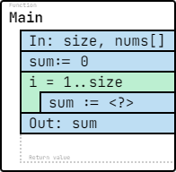

Answer: sum + nums[1]

5. What is missing in the following specification? (What would you write instead of <?>)
In: size ∈ N, nums ∈ Z[1..size]
Out: sum ∈ Z
Pre: size > 0
Post: sum = SUM(<?>)

Answer: i=1..size, nums[i]

